## Select Cardiff & Vale University

## View Contact then click Survey

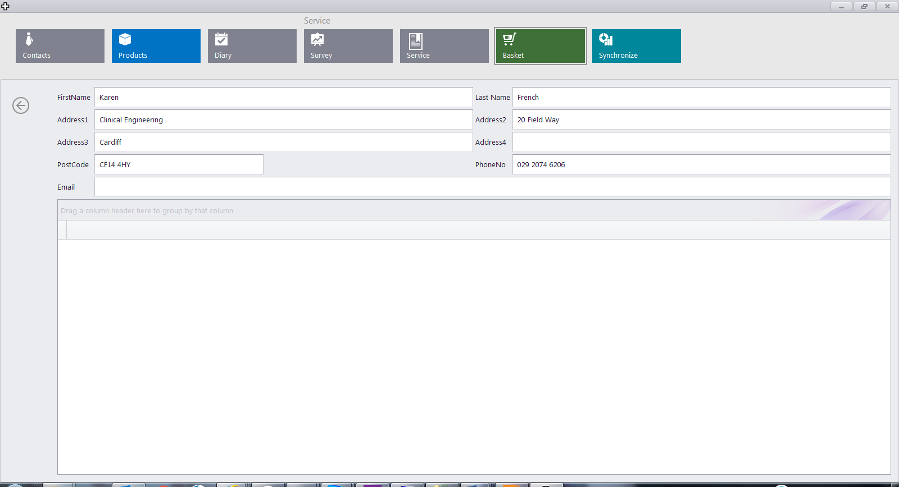

## Click + Icon for new Survey or Double Click Existing Survey

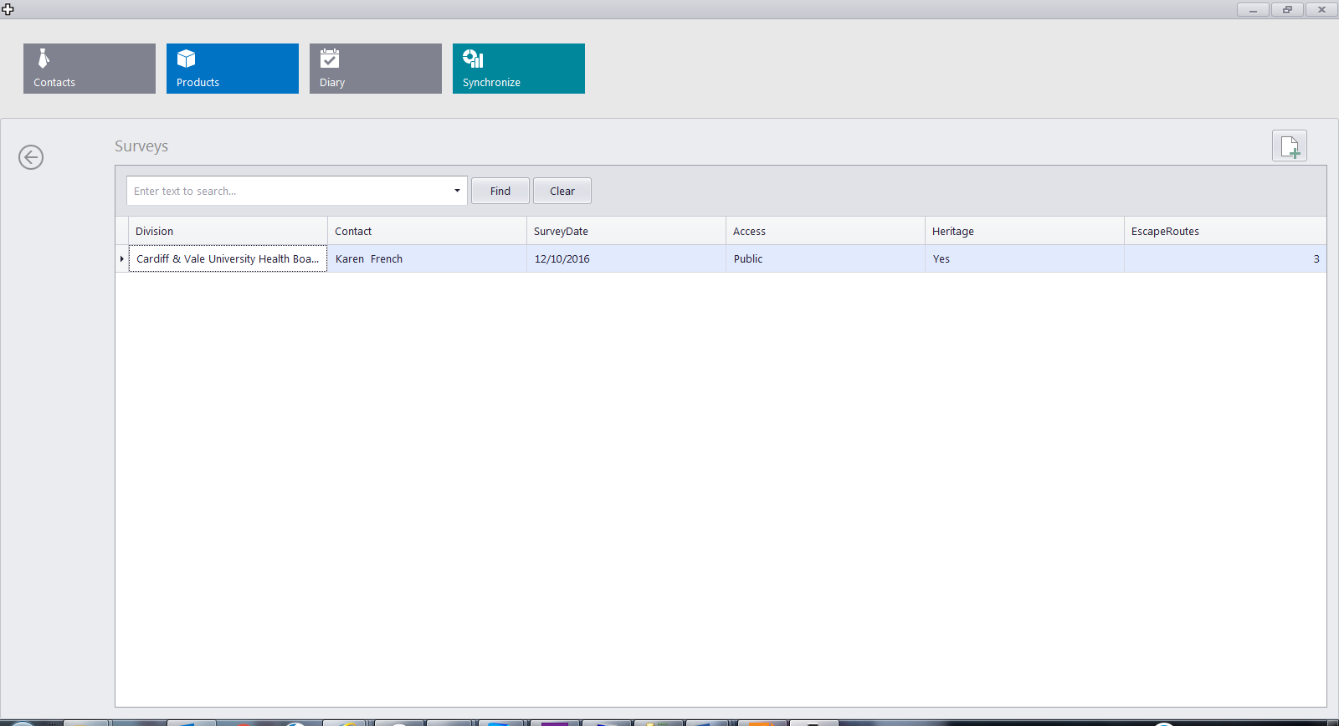

## Edit Details and or Double Click an Escape Route

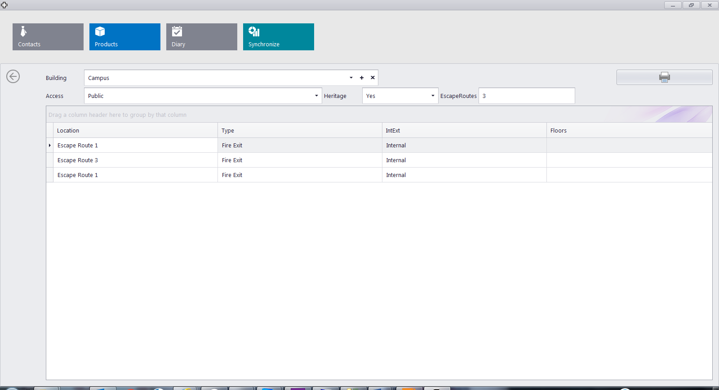

## Double Click Floors to Edit

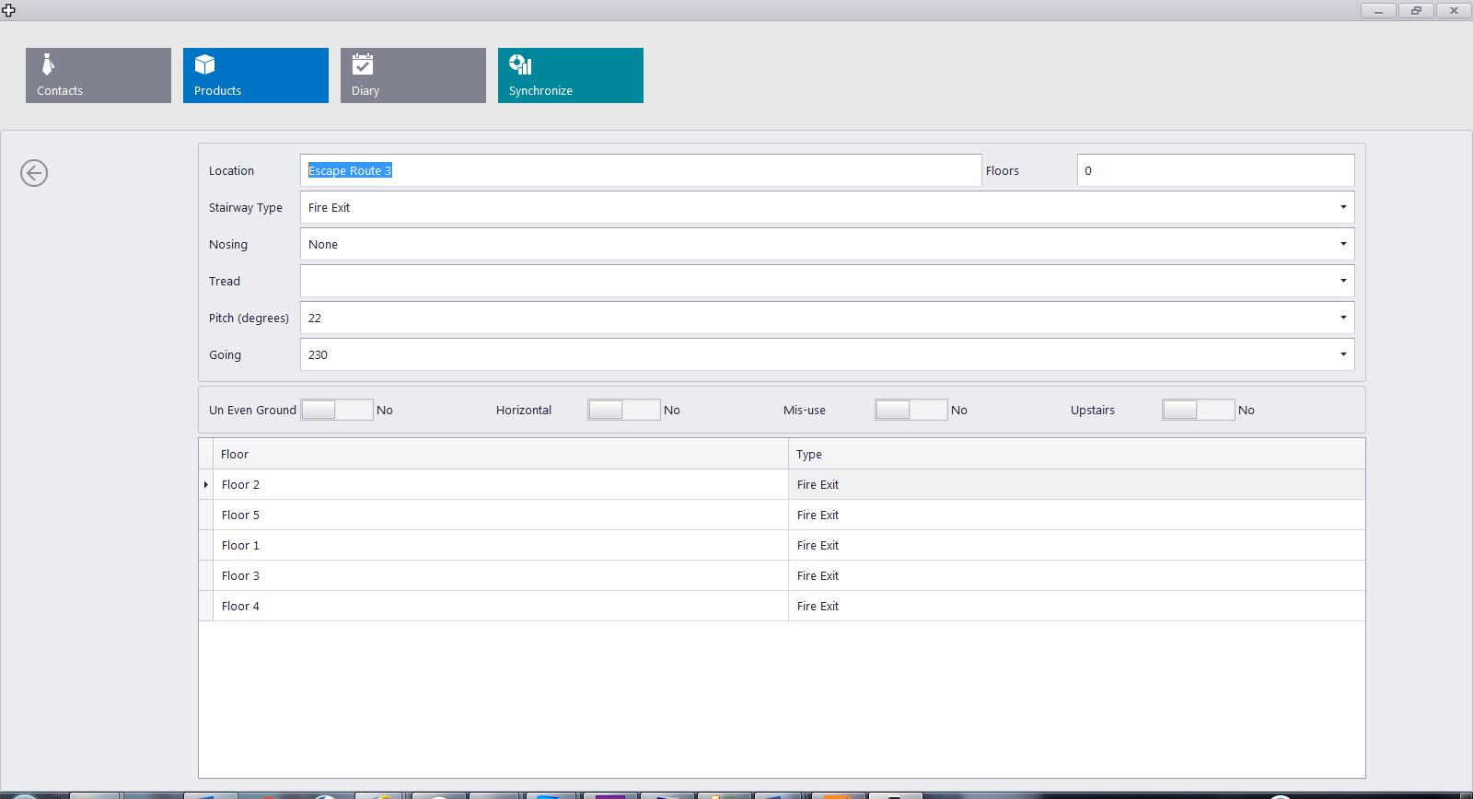

Use the Back Arrow to Save and return to Previous Screen 